Assignment 2: Domain Class Diagram

Yilong Yu – Ben Powers – [Jaehyun](javascript://) Park

8170995 – 7986250 – 8105702

Systems Analysis and Design / INFO2320

[David Turton](https://conestoga.desire2learn.com/d2l/le/content/229806/viewContent/4630975/View) / [Sachin](javascript://) Parikh

October 3rd, 2018

Team Name: Scoopy-doo

Teacher Name: [Sachin](javascript://) Parikh

Due: Oct 03, 2018 6:00 PM

# Systems Analysis & Design – Assignment 2: Domain Class Diagram

You are working with the case **Spring Breaks ‘R’ Us** (**SBRU**) Travel Service. The four major subsystems of the solution being proposed are:

* Resort Relations
* Student Booking
* Accounting & Finance
* Social Networking

## Chapter 4 Questions – (page 127)

1. List the domain classes and their attributes that would be required to support the Social Networking subsystem as described in the text on page 127. Be creative and add those you think should be included to make the system useful and appealing.

|  |  |  |  |  |
| --- | --- | --- | --- | --- |
| **Class Name** | **Student** | **Schools** | **Content** | **Friends** |
| **Attributes** | studentId | schoolId | contentId | friendId |
| firstName | schoolName | name | studentId |
| lastName | Address | type | name |
| DOB | City | size | phoneNumber |
| gender | Province | path | email |
| address | Country | uploadDateTime |  |
| city | postalCode |  |
| province | phoneNumber |
| Country | Email |
| postalCode | website |
| phoneNumber |  |
| email |
| **Class Name** | **Post** | **Group** | **Interests** |  |
| **Attributes** | postId | groupId | interestId |
| contentId | groupName | name |
| title | groupCapacity | type |
| postDateTime | groupInterest |  |
| description |  |

1. Based on the domain classes you identified, draw a Domain Class Diagram showing the domain classes & associations along with their attributes and multiplicity.

Please check the Domain Class Diagram below.

1. <new, not in text> Include a copy of your Event and Use Case diagrams for the *Booking* subsystem from your first assignment (so the teacher knows where you’re coming from). Draw a Domain Class Diagram to support your Booking subsystem with domain classes & associations along with their attributes and multiplicity.
   1. Since there will be some overlap with the classes to support the Networking subsystem, you can create a single diagram for both.

Events list and Use Case Diagram of Assignment 1, please check Domain Class Diagram below.

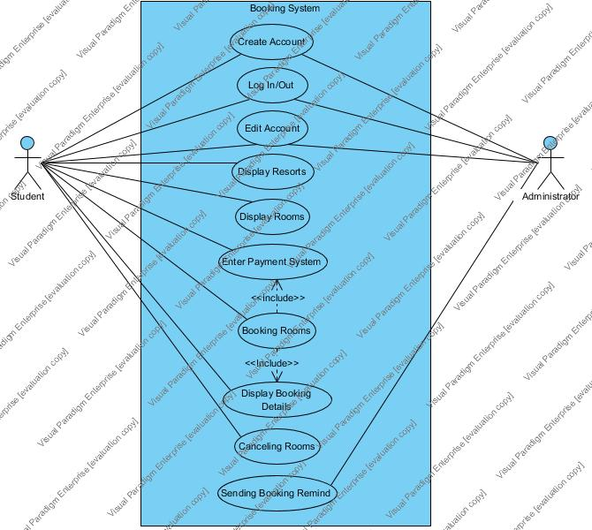

|  |  |  |
| --- | --- | --- |
| **a. Event Name** | **b. Event Type** | **c. Use Case** |
| Student create account | External | Create Account |
| Student log in/out account | External | Log in/out Account |
| Student edit account profile | External | Edit Account |
| Student browse resorts | External | Display Resorts List |
| Student browse available rooms | External | Display Rooms List |
| Student book rooms | External | Booking Rooms |
| Student view booking details | External | Display Booking Details |
| Student enter payment subsystem | State | Entering Payment Subsystem |
| Student Cancel booking | External | Canceling Rooms |
| System send booking remind | Temporal | Sending Booking Remind |

## 

Hand In

* Zip your answers into a single file and upload it to the assignment folder on eConestoga … only have one team member upload per team.
* Hand the marking sheet in during the lab period for the week its due, with your team name, lab section number and teacher name.